ISSN 1220 - 8434 ACTA TRIBOLOGICA
Volume ??, (????), ??-??

Sergiu SPINU¹  e-mail: sergiu.spinu@fim.usv.ro  Put second author here, if applicable²  ¹ Department of Mechanical Engineering,  University of Suceava,  ROMANIA  ² Put second author’s affiliation here, if applicable | Put Title of the paper here  Abstract. These instructions provide basic guidelines to help possible contributors prepare their final camera-ready papers for submission to the Acta Tribologica Journal. Abstracts should be self-explanatory and summarize the essential qualities of the papers. They should give a clear indication of the objective, scope, and results of the paper, so that the reader will have a clear concept of the paper's chief purpose.  Keywords: five key words or phrases separated by commas, for indexing, abstracting, and retrieval purposes

1. INTRODUCTION

Prospective authors are invited to submit papers that fit within the scope of the journal. Papers should be written in English and submitted in final camera-ready form.

2. Page FORMAT

Margins: top 2.5 cm, bottom 2.5 cm, left and right 2.5 cm, gutter 0 cm. Orientation: portrait. Paper size: A4.

3. BODY OF THE PAPER

Line spacing: single. Text organization: two columns. Column width: 7.5. Space between columns: 1 cm. Last page columns must be equal in length.
The text should be organized into logical parts or sections, with emphasis on the following matters: the purpose of the paper, description of the problem, the means of solution, results and the author's conclusions.
In order to divide the paper into logical parts, numbered headings and subheadings should appear throughout the paper. However, the nomenclature, acknowledgements, references and appendix sections should not be numbered.
When using enumerations, in order to create a graphic impression, individual items should be identified as (1), (2), (3), etc., or as (a), (b), (c), etc.

3. TABLES, FIGURES, EQUATIONS

Figures and tables should be numbered consecutively, following the order cited in the text; they may be organized in one or two columns. An empty line should be placed before and after every figure or table.
Figures must be accompanied by a caption placed underneath, consisting of the figure number and a brief title or description of the figure. This number should be used when referring to the figure in text. Figures should be referenced within the text as "Figure 1". An empty line between the figure and the caption is required.
Figures (illustrations, graphs, photographs, etc.) must be submitted camera ready. They should be clear and sharp and of best available quality. As ACTA TRIBOLOGICA does not generally print in full-color, all figures should be designed for reproduction in black and white. However, full color is acceptable for the electronic version of the journal.

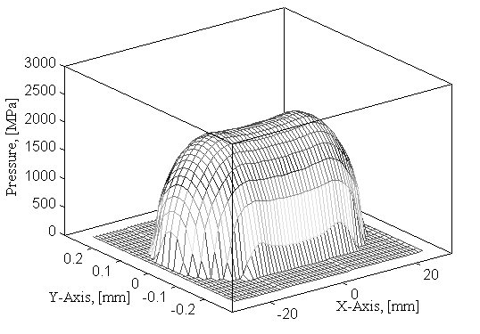

Figure 1. Pressure distribution, partial crowning

Tables may be inserted as part of the text, or included at the end of the paper as an appendix. They must be accompanied by a caption placed at the top, consisting of the table number and a brief title or description of the table. This number should be used when referring to the table in text.

Table 1. Recommended Fonts
Item | Font | Size | Style
Title of the paper | TNRoman | 12 | Bold, All Caps
Authors’ first names | TNRoman | 10 | Bold
Authors’ last names | TNRoman | 10 | Bold, All Caps
Authors’ affiliation | TNRoman | 8 | Regular
Abstract | TNRoman | 10 | Regular
Titles of sections | TNRoman | 10 | Bold, All Capss
Text, equations | TNRoman | 10 | Regular
Algorithms | Courier New | 10 | Regular

Equations should be numbered consecutively beginning with (1) to the end of the paper, including any appendices. The number should be enclosed in parentheses (as shown above) and set flush right in the column on the same line. This number should be used when referring to equations within the text.
In all formulas and equations, any symbols (and the units in which they are measured) not previously defined in nomenclature should be explained. Only SI units of measurement should be used.
Equations should be kept to a reasonable minimum. Complex mathematical formulas should be developed in appendices rather than in the body of the paper.
An empty line should be placed before and after every equation.
References must be placed at the end of the paper and comply with the model below. Within the text, references should be cited in numerical order according to their order of appearance. The numbered reference citation should be enclosed in brackets.
In the case of two citations, the numbers should be separated by a comma [1,2]. In the case of more than two consecutive references, the numbers should be separated by a dash [3-5].

Nomenclature

A nomenclature section of the paper is not compulsory, as soon as any symbols used in formulas and equations are explained within the text. If present, the nomenclature list should be in alphabetical order (capital letters first, followed by lowercase letters), followed by any Greek symbols, with subscripts and superscripts.

ACKNOWLEDGEMENT

Acknowledgements to individuals or institutions that have made an important contribution should be placed before References.

REFERENCES

- Polonsky, I.A., and Keer, L.M., 1999, “A Numerical Method for Solving Rough Contact Problems Based on the Multi-Level Multi-Summation and Conjugate Gradient Techniques,” Wear, 231, pp. 206-219.
- Johnson, K.L., 1985, Contact Mechanics, Cambridge University Press.
- Kawabata, S., Nakamura, T., 2003, “New Iteration Method for FFT Based Contact Analysis,” Proc. of 2003 STLE/ASME International Joint Tribology Conference, Ponte Vedra Beach, Florida USA.

APPENDIX A

Appendices, if present, must be marked A, B, C, and placed after References. It is of the greatest importance that all technical, scientific, and mathematical information contained be checked with the utmost care.

